
Mid-Term Examination | Fall |  | 2022

 | Program: | BS Computer Science |  |  |  |  | Class: |  | BSSE I B
 | Course Name: |  |  | Fundamental of Programming |  |  | Duration: |  |  | 2 hours
 | Instructor’s Name: |  |  |  | Asim Riaz |  | Total Marks: |  |  |  | 20
 | Course Code: |  | CSC1103 |  |  |  | Date: | 15 November 2014

IMPORTANT instructions:
- Read all questions carefully first and then ask for clarifications.
- Question paper related queries will not be entertained after 15 minutes in case of hourly/test exams and 30 minutes for mid-term/final exam after start of paper.
- Do not write anything on question paper unless until specifically asked for.
- Marks of each question are mentioned at the end of each question.
-------------------------------------------------------------------------------------------------------------------------------------------------------------
 | Write a program which take infinite (non-zero) integers until you entered 0 and print total and average of all inputs? | 7 marks
Generate The Following Input
7 Marks

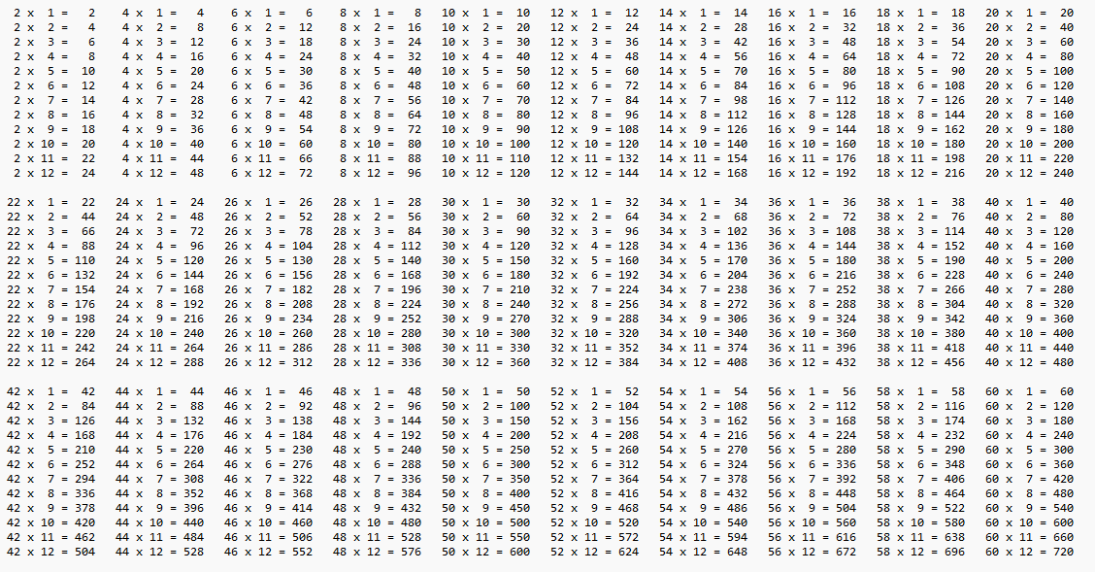
6 Marks
